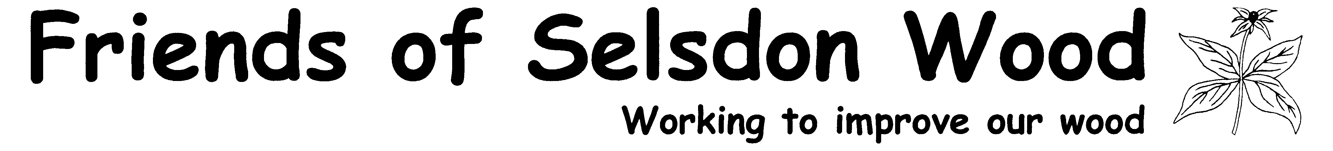

Volunteers H&S Advice Card - Safety comes first!
1. If you volunteer, you are responsible for your own and your co-workers safety at all times.
Remember – fire burns, sharp tools cut, heavy tools bruise, you can trip, trees are heavy, mud is slippery.
2. You are responsible for using the correct tool for the job and using it safely. If you do not know how to use your tools, it is up to you to tell the Leader.
3. You are responsible for ensuring nothing in the working environment is detrimental to your health and informing the Leader if you have health problems.
4. Safety equipment is available - hard hats, safety googles, high viz jackets. It is your responsibility to use them.

Volunteers H&S Advice Card - Safety comes first!
1. If you volunteer, you are responsible for your own and your co-workers safety at all times.
Remember – fire burns, sharp tools cut, heavy tools bruise, you can trip, trees are heavy, mud is slippery.
2. You are responsible for using the correct tool for the job and using it safely. If you do not know how to use your tools, it is your responsibility to tell the Leader.
3. You are responsible for ensuring that nothing in the working environment is detrimental to your health and informing the Leader if you have health problems.
4. Safety equipment is available - hard hats, safety googles, high viz jackets. It is your responsibility to use them.

Volunteers H&S Advice Card - Safety comes first!
1. If you volunteer, you are responsible for your own and your co-workers safety at all times.
Remember – fire burns, sharp tools cut, heavy tools bruise, you can trip, trees are heavy, mud is slippery.
2. You are responsible for using the correct tool for the job and using it safely. If you do not know how to use your tools, it is your responsibility to tell the Leader.
3. You are responsible for ensuring that nothing in the working environment is detrimental to your health and informing the Leader if you have health problems.
4. Safety equipment is available - hard hats, safety googles, high viz jackets. It is your responsibility to use them.

5. You are responsible for the following,
to maintain a safe working environment:
a. Try to work in pairs to watch out for each other.
b. Remove trip hazards when starting to work -
smaller branches, twigs and plants (brash) must be stacked for insects or burned.
c. Be aware of the fire - avoid burning yourself, your clothing or your co-workers.
d. Look out for flaring or sparks when you or others add fuel to the fire.
e. Be aware when you or others cut timber that it does not fall on yourself or others.
f. Be aware when timber is being carried to avoid causing or having accidents.
H&S card 29.11.14

5. You are responsible for the following,
to maintain a safe working environment:
a. Try to work in pairs to watch out for each other.
b. Remove trip hazards when starting to work -
smaller branches, twigs and plants (brash) must be stacked for insects or burned.
c. Be aware of the fire - avoid burning yourself, your clothing or your co-workers.
d. Look out for flaring or sparks when you or others add fuel to the fire.
e. Be aware when you or others cut timber that it does not fall on yourself or others.
f. Be aware when timber is being carried to avoid causing or having accidents.
H&S card 29.11.14

5. You are responsible for the following,
to maintain a safe working environment:
a. Try to work in pairs to watch out for each other.
b. Remove trip hazards when starting to work -
smaller branches, twigs and plants (brash) must be stacked for insects or burned.
c. Be aware of the fire - avoid burning yourself, your clothing or your co-workers.
d. Look out for flaring or sparks when you or others add fuel to the fire.
e. Be aware when you or others cut timber that it does not fall on yourself or others.
f. Be aware when timber is being carried to avoid causing or having accidents.
H&S card 29.11.14

